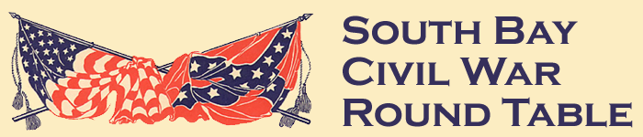**South Bay Civil War Roundtable**

**Meeting Minutes January 27, 2015**

**Meeting Location**: Holder’s Country Inn – Cupertino, CA

**Special Activities & Events:**

**2015 West Coast Civil War Conference**

No Report

**Officer Reports**

**President**

* Welcoming message to members & invited guests
* 25th year / 287 meeting
* Received Thank You letter from Sacramento Civil War Roundtable regarding our donation to help fund their 2014 West Coast Civil War Conference
* Because of the large number of books that have been donated, some portion which are raffled off at each meeting, it was suggested setting up a “Lending Library” for Club members to check out books of interest.

**Vice President(Vacant)**

No Report Given

**Treasurer**

* Advised members that anyone who still has not paid their 2014-15 dues needs to make that payment to the Treasurer as soon as possible

**Secretary**

* Distributed November meeting minutes
* Civil War Quiz: What Do You Know About Robert E Lee?
* $59 collected for book raffle
* Meeting Attendance:

Total: 25; Guests: 4; New Members: 2

**(Continued on back side)**

**Publicity Director(Vacant)**

No Report Given

**Preservation**

Bill Noyes reported that the Trevilian Station Battlefield Foundation has announced an effort to acquire 70 acres of the battlefield which is located in Louisa County, Virginia about 50 miles northwest of Richmond, VA

**Publicity/Membership(Vacant)**

No Report Given

**Historian**

No Report Given

**Other Topics**

**Ted Savas Fund Raising Suggestion**

* Club purchases Civil War books at a discount and then sells them at meetings for a profit
* Provided members with copies of Ted’s email for review; will be a discussion topic at a future SBCWRT meeting

**Civil War News Newspaper**

* Gary Campagna distributed several copies of a recent Civil War News Newspaper

**January Presentation**:

Speaker: Robert Burch

Topic: A Little Battle at Big Bethel – Part 1

**February Presentation**:

Speaker: Robert Burch

Topic: A Little Battle at Big Bethel – Part 2

**January Presentation**:

Speaker: Steve Batham

Topic: Catalina Island in the Civil War